1.How do you continuously monitor the latest entries in a log file, such as /var/log/syslog ?

For tail default value is 10 from bottom

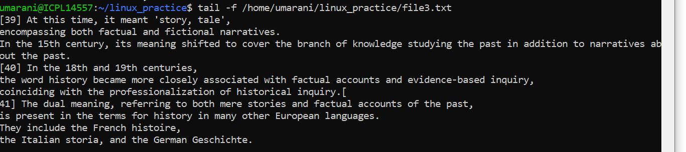

Question 2: How can you display the last 50 lines of a file instead of the default 10?

tail -n 50 /home/umarani/linux_practice/file1.log

-->result will be the bottom 50 lines of the logs

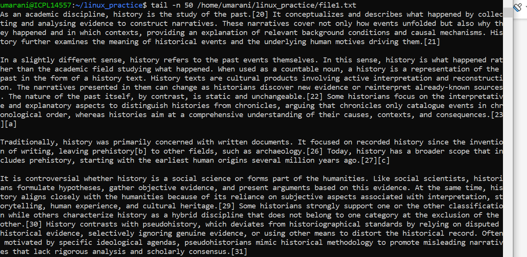

How do you view the first 20 lines of a log file?

-->head -n 5 /home/umarani/linux_practice/file3.log

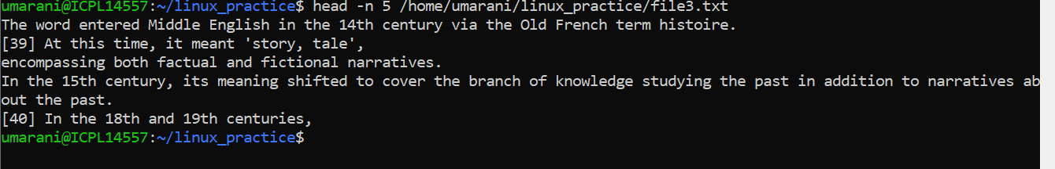

question 2: How do you combine head and tail to extract lines 11 to 20 from a file?

-->head -n 20 /home/umarani/linux_practice/file3.log|tail -n 10

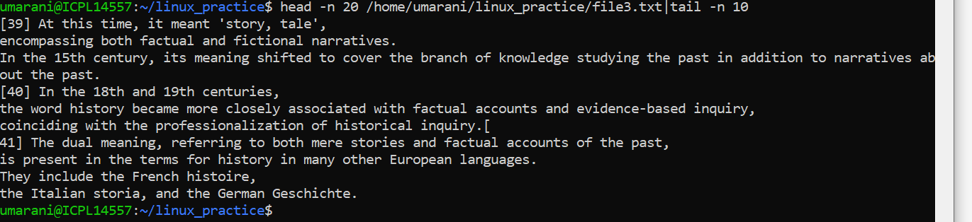

How do you find all log entries in /var/log/syslog containing the word “error”?

Grep “error” /home/umarani/linux_practice/file1.log

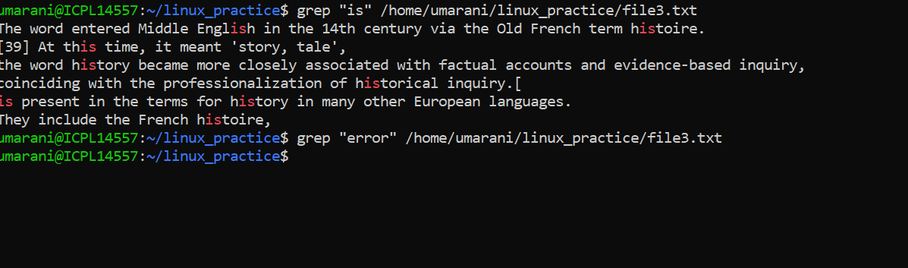

How can you search for log entries case-insensitively?

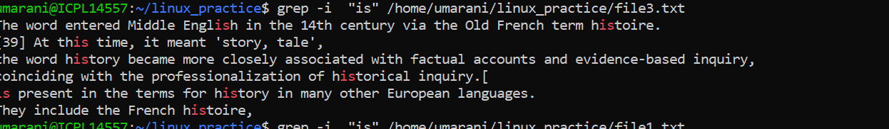

How do you navigate a large log file one screen at a time?

By using less

-->less /home/umarani/linux_practice/file4.log

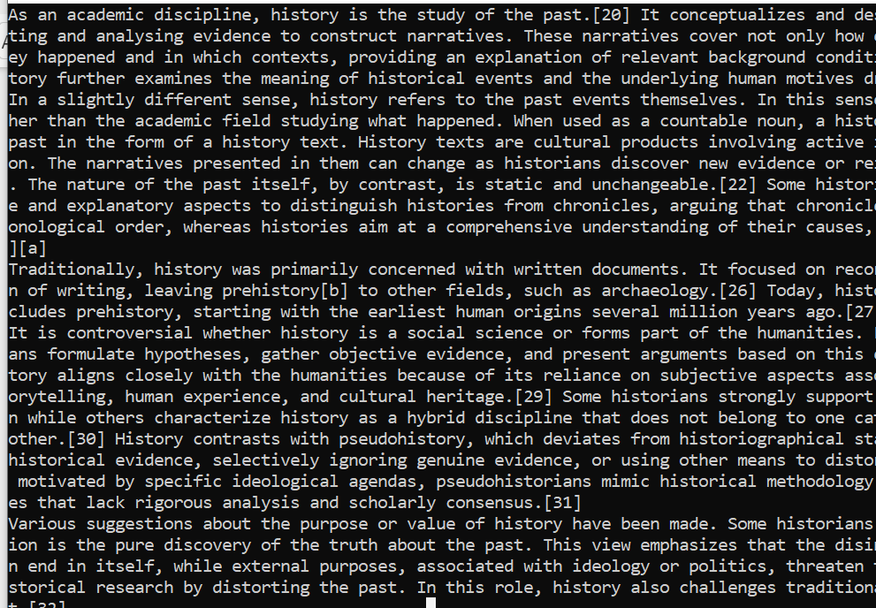

How can you search for the word “failed” within a file opened in less ?

/in

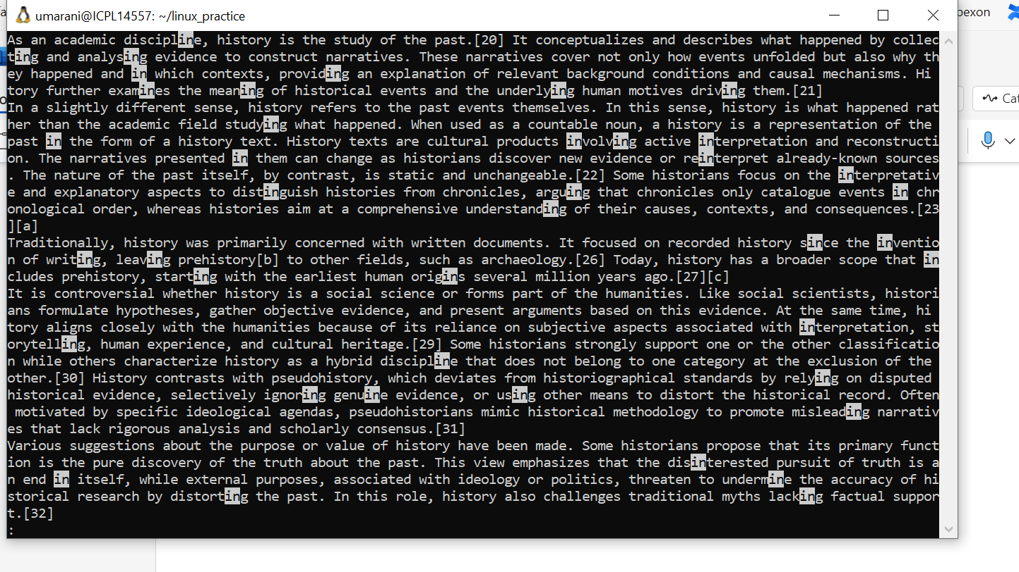

cat – Concatenate and display file contents.

--->cat home/umarani/linux_practice-->this is not suitable for large files

How do you combine multiple log files and save the output to a new file?

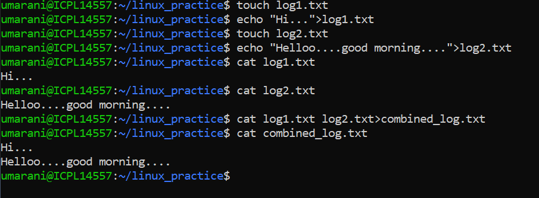

How do you view the systemd logs for the last boot session?

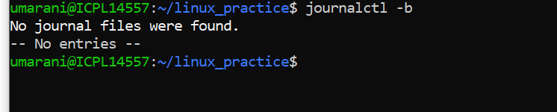

How can you filter systemd logs by a specific service, like nginx.service ?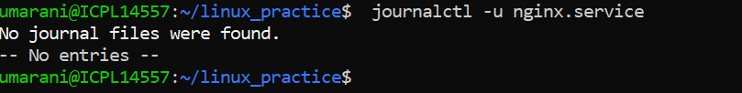

How do you manually add a message to the system log?

--->cat /home/umarani/linux_practice/file4.log | grep "System maintenance scheduled at m

idnight"

How can you add a message to the system log and specify a priority?

You want to monitor real-time logs of a web server to debug an issue.

-->tail -f /home/umarani/linux_practice/file2.txt

tail -f /var/log/nginx/access.log

tail -f /home/umarani/linux_practice/error.log

A file is too large to open directly, and you want to quickly check the first and last 10 lines.

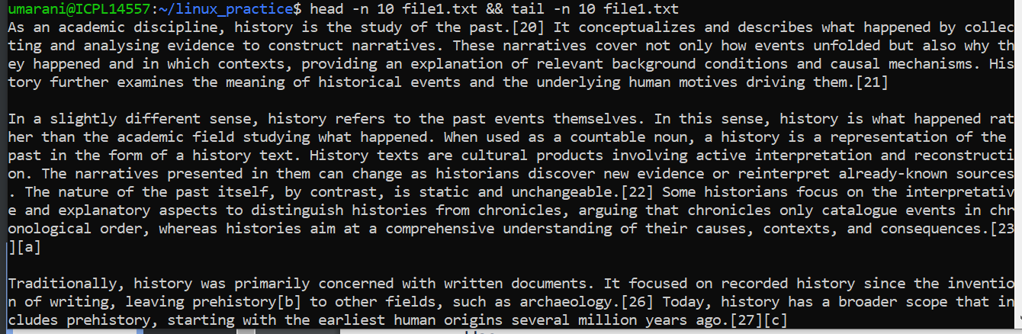

You suspect a service (e.g., ssh.service ) is failing to start. Check its logs using:

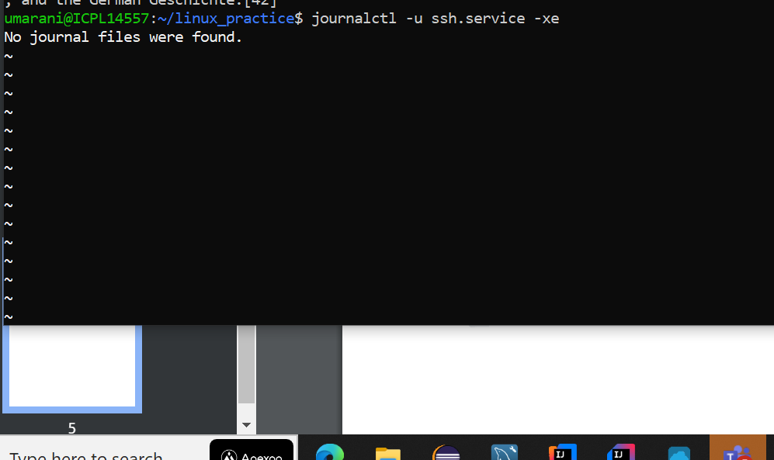

To find all occurrences of the word “failed” in logs for analysis:

Here i am searching for hello

grep -i "hello" /home/umarani/linux_practice/combined_log.txt

